Handle Types

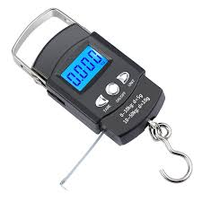 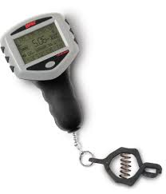 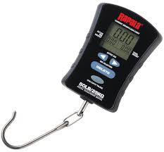 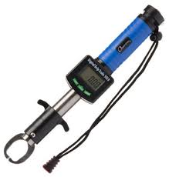

Griper styles

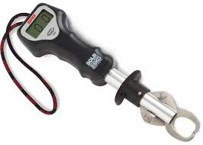 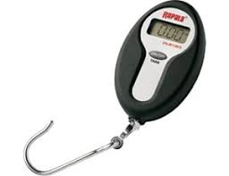 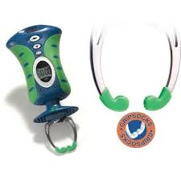 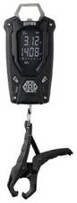

LED screen placement

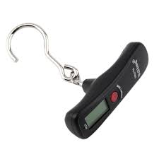 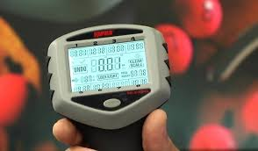 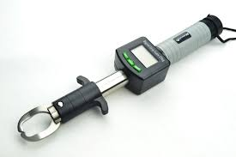 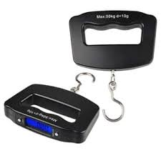

Size

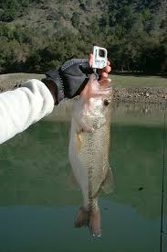 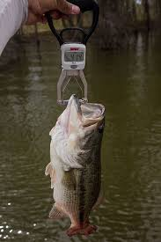 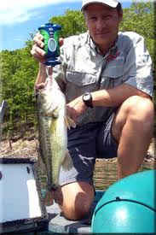 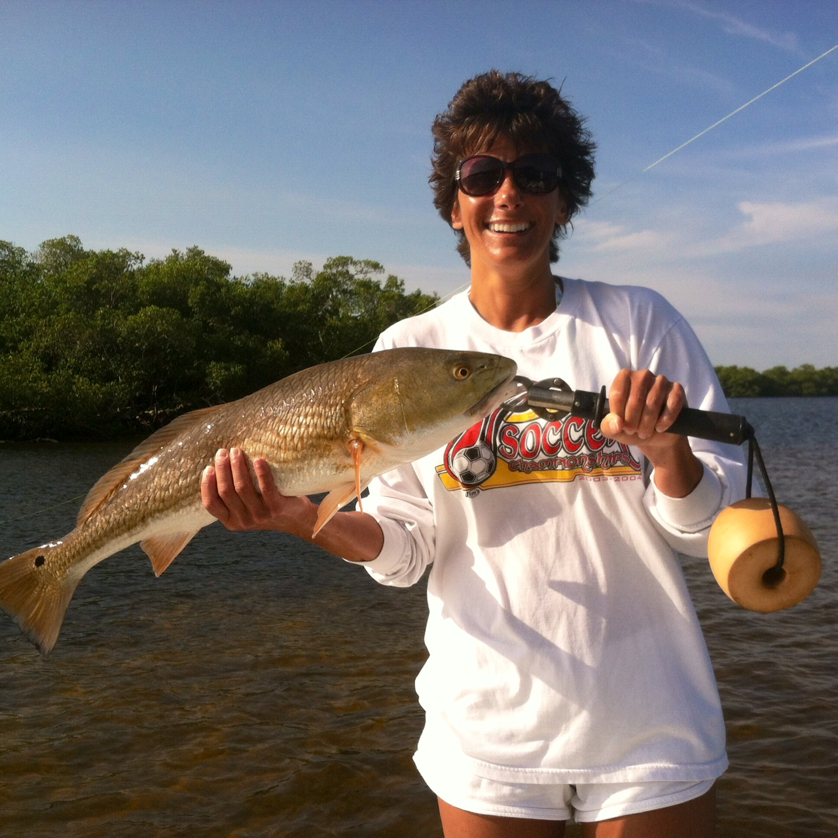

Aesthetic Concepts

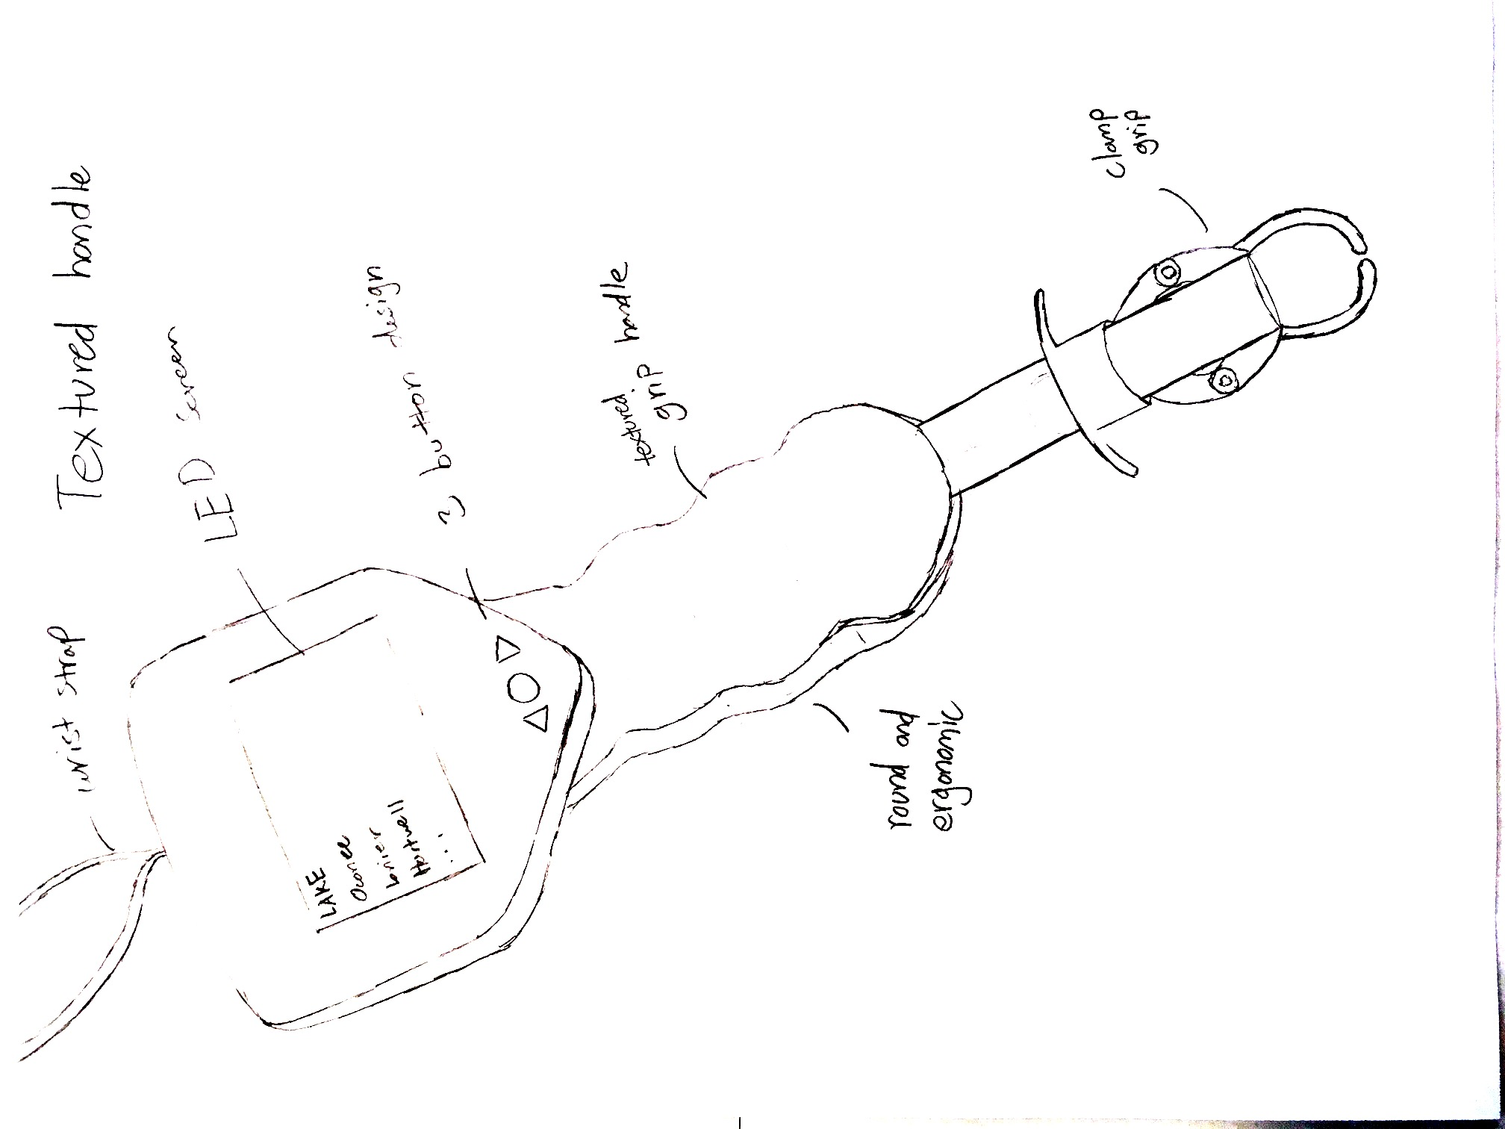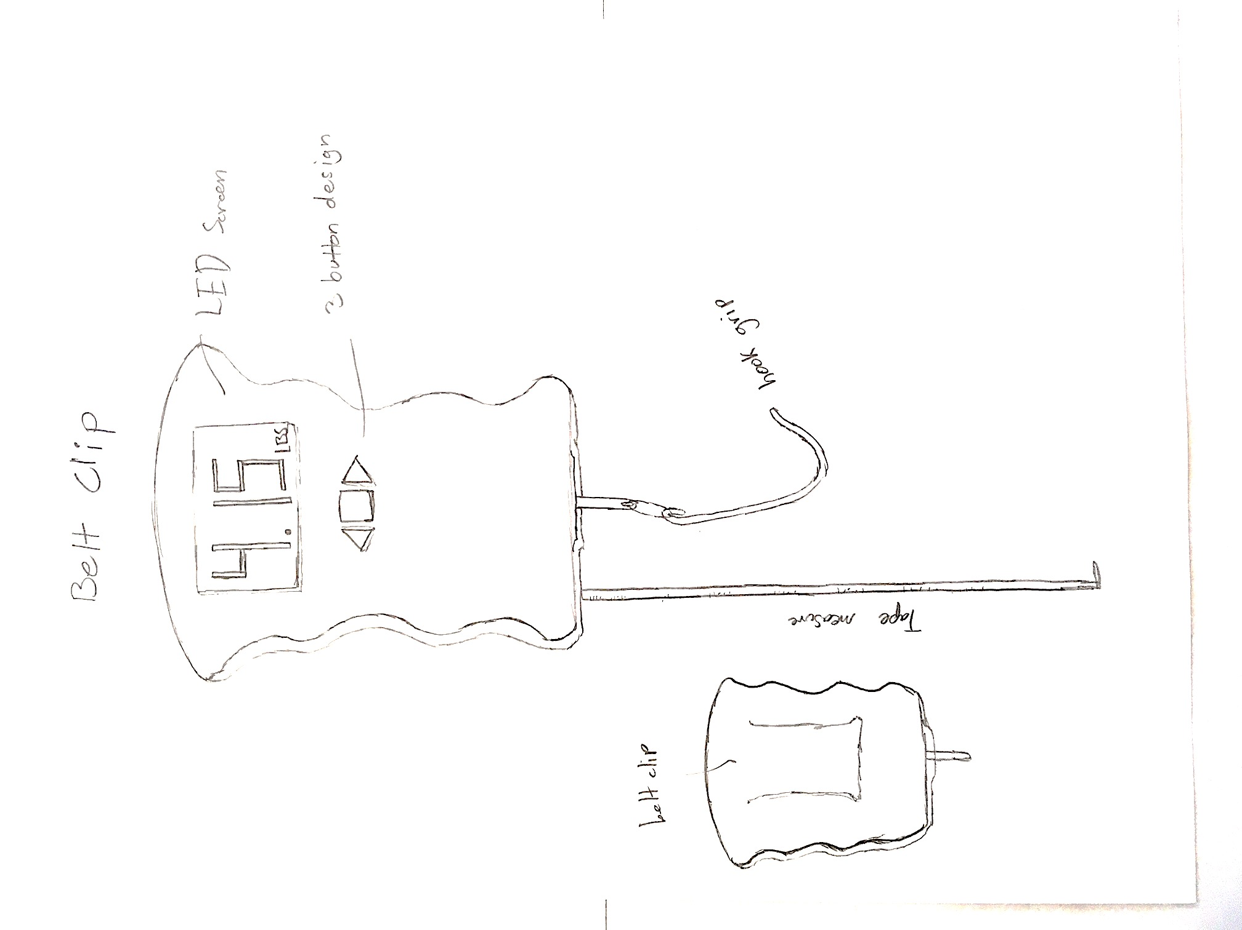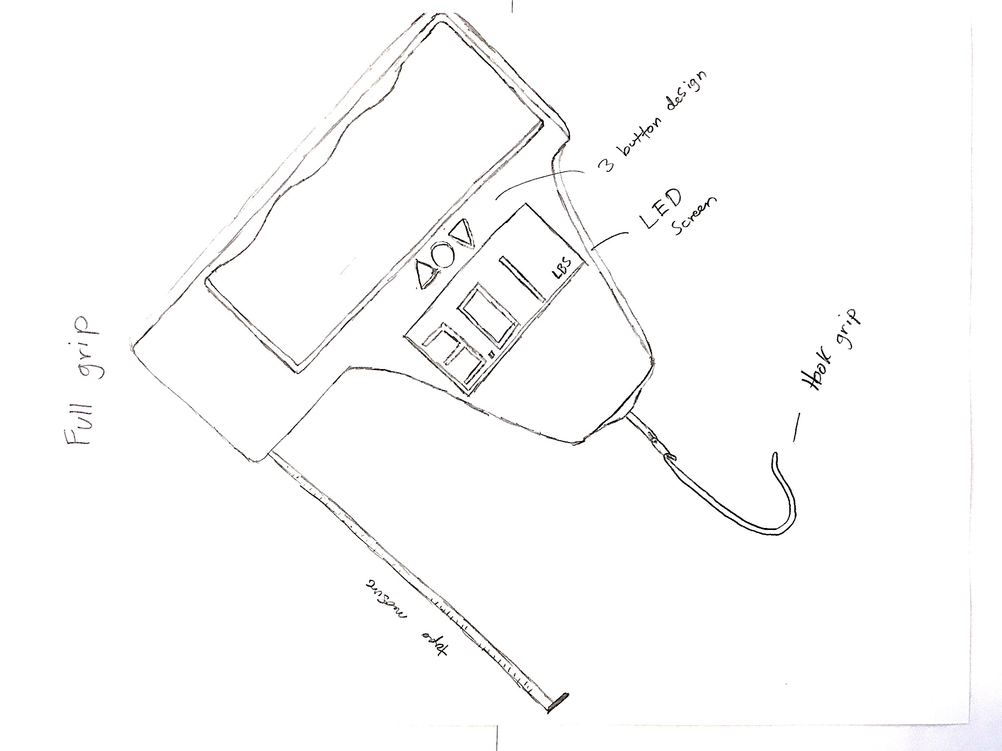

Concept Summary

In order to see all of the regulations and slot limits for each lake I think I am going to need a fairly large screen. Saying this I think that all three of the concepts I came up with allow for a large screen. And hope to include that in my design. I am still deciding, however, how I want to hold the device. Either with a handle or hold the whole device, but I think I am going to go with a simple hook grip so that you can weigh multiple kinds of fish. I also really like the tape measure since that’s how many fish are gauged as to whether you can keep them or not. And I plan to include the 3-button design with the up and down arrows to navigate the LED screen.

**PROS CONS**

Textured Handle

Ergonomic design Large

1 handed use Grip doesn’t accommodate every species of fish

Sturdy gripping device

Belt Clip

Tape measure included Not as secure of a hand hold for large fish

Clips on when not in use Fish can flop off grip

Tried and true grip

Full Grip

Sturdy hand hold Must use two hands

Tape measure included Hand in the way of LED screen maybe

Tried and true grip Fish can flop off grip